On-premises Linux add to the Aws systems manager

1. Create a hybrid activation
2. Required details need to be fill in the hybrid activation

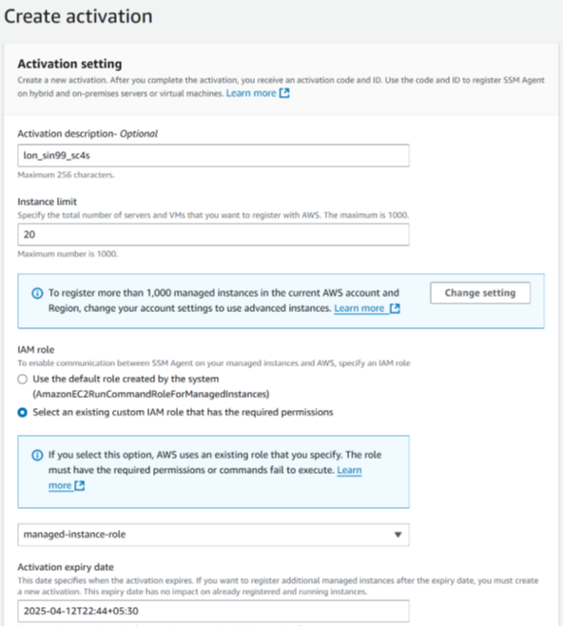

1. Add the IAM role
2. Activation id and code validate for one month

1. Click to create activation

Once created an activation id and code keep it safely

1. Package should install based on the architect of os amd_64 (64-bit) or 86X64
2. Login into the server install the ssm agent based on the OS like ubuntu, centos redhat. Should check in the Aws URL
3. Agent version: amazon-ssm-agent –version

Run the below command should change the activation code and id

amazon-ssm-agent -register \ ----press enter

-code "UUZrYgMBolXhS1D25Kqq" \ ----press enter

-id "b0188625-c017-4a9a-b427-37f9380c281d" \ ---press enter

-region "us-east-1" finally enter

Id will be created like mi-123456789 then check the fleet manager unless you should restart the ssm service

Systemctl status amazon-ssm-agent

Systemctl start amazon-ssm-agent

Systemctl restart amazon-ssm-agent

Create a tag

Create a hostname

Scan the server that would be fine.